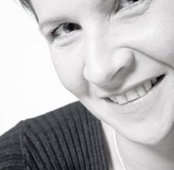

Breaking Barriers

Rompere le barriere della dislessia

Roccalumera – Antica Filanda - 26 Settembre 2011

Morning section 9.00-12.00

Welcome
Autorità: Deputazione Reg. e Naz ., Provincia
Sindaco Comune Roccalumera, Giovanni Miasi
Delegato Distretto Sicilia Lions Club International
Ufficio Provinciale Scolastico, Carmela Ursino

- The Italian Dyslexia Association Grazia Restuccia (10 minutes)
- Dyslexia: a lifelong condition Antonella Gagliano (15 minutes)
- Breaking Barriers: the project Eeva Siirala (15 minutes)
- The state of the art in European Countries Holanda, Finland, Norway, Estonia,Turkey
(10 minutes for each country)
- Peer Learning: practices and experiences Irma Kakkuri (15 minutes)
- The diagnosis of Dyslexia in adulthood Enrico Ghidoni (30 minutes)
- Dyslexia in adulthood Giacomo Stella (45 minutes)

12.00-13.00 Open Discussion

13.00-14.00 Lunch break

Afternoon section 15.00-16.30
- What about legislation Carlo Mastroeni (15 minuti)
- Assistive technology and helping devices Luca Grandi (45 minuti)
- Practical Solutions for Higher and Further Education Giacomo Cutrera (30 minuti)

16.30-17.00 Question Time

17.00-19.00 Proiezione del Film “Like Stars on Earth” (Stelle sulla Terra)

Il 27 mattina I lavori del Gruppo Breaking Barriers proseguiranno al Policlinico Universitario di Messina.

