Top of Form

GRUNDTVIG/ COMENIUS SEMINAR
CY-2009-037-001

LEARNING IN LATER LIFE
GENERATIONAL COOPERATION

22-26 April 2009, Larnaka City, Cyprus

Introduction
In the context of an ageing society young and old are more and more faced with new learning needs of older adults and vice versa. Older adults- even if they are not willing to learn-are forced to cope with the changes of modern life to keep social contacts. It brings chances and challenges, but also risks and threats for young and old. This unique situation in history of mankind requires learning process focused on ageing as well as focus on intergenerational links. This is a complete new challenge to adult educators, teachers, trainers, facilitators, as well as to learners and students from all ages. Special competencies are therefore needed.

Trainer
Jim Soulsby. Jim has worked in the field of learning in llater life for over 20 years. Working with NIACE (National Institute for Adult Continuing Education), Jim developed international interest in specialist educational opportunities for older people. Prior his work at NIACE Jim was based at the University of Central Lancashire. He is currently the development coordinator for the Association for Education and Ageing (AEA) and also facilitates or advises on a range of older learners initiatives.

Details
Deadline for applications to the National Agencies is 31 January 2009
Contact: Klitos Symeonides, President of the Cyprus Adult Education Association (seminar-course manager), email: klitossy@cytanet.com.cy, tel. 00357-99470810,
fax 00357-22486714
In order to apply for funds to cover all expenses, you need a letter of acceptance from the seminar manager. For all information about the seminar look at web:
http:/ec.europa/education/trainingdatabase/search/ctm,
then search for seminar: CY-2009-037-001
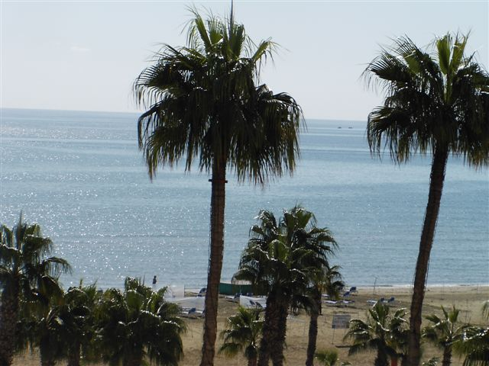 | 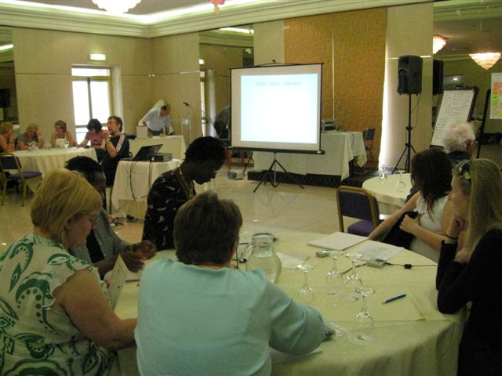
View from seminar hotel | Participants at the seminar “Learning In Later Life”,  26-30 March 2008 Larnaka

Course Information
Reference Number : CY-2009-037-001
TITLE OF THE TRAINING ACTIVITY
IN THE LANGUAGE OF TUITION
English : | LEARNING IN LATER LIFE-INTERGENERATIONAL COOPERATION

TYPE OF TRAINING ACTIVITY
TRAINING AIMED AT PARTICIPANTS RECEIVING
A GRANT FOR EITHER COMENIUS OR GRUNDTVIG TARGET GROUPS
ORIGIN OF THE TRAINING
COURSE RESULTING FROM A PREVIOUS SOCRATES PROJECT (COMENIUS, LINGUA, ADULT EDUCATION, GRUNDTVIG, ERASMUS, MINERVA)
SOCRATES PROJECT NO. : | 110301-CP-1-2003-NL-GRUNDTVIG-G4

THEMATIC FIELD OF THE TRAINING
GENERAL IN-SERVICE TRAINING
School management, school autonomy
Career guidance and counselling
School improvement & quality evaluation
Pedagogy and didactics
Intercultural education
Gender training
Inclusive approaches
European citizenship & European dimension
Courses on adult literacy/basic skills
Specific target groups: gypsies, travellers, occupational travellers & migrants
Education for parents/family education
Active citizenship
Education management/project management

LANGUAGES USED FOR THE TRAINING
MAIN LANGUAGE:
OTHER LANGUAGE/S USED DURING THE TRAINING:
English

LANGUAGE VERSION(S) IN WHICH MATERIALS WILL BE PROVIDED:
English

EDUCATION SECTOR OF THE TRAINING PARTICIPANTS
SCHOOL AND PRE-SCHOOL EDUCATION
Primary
General secondary
Vocational/Technical secondary
Special education for disabled persons
ADULT EDUCATION
Adult education provider
Second chance or remedial education
Adult education for disabled persons
Higher education institution offering outreach courses for adults
Organisations working with migrant groups/ethnic minorities
Centres for guidance, councelling or accreditation
Other sectors of adult education

TARGET AUDIENCE
Teachers (Pre-school, primary, secondary, vocational, adult, special needs)
Teacher trainers
Careers officers, educational guides and counsellors
Inspectors
Headteachers/principals/managers of schools/organisations offering adult education
Other (Paid or voluntary) management staff in the institution/organisation
Non-teaching administrative staff
Members of students/teachers councils in adult education

INSTITUTION ORGANISING THE TRAINING
NAME OF THE ORGANISATION: | CYPRUS ADULT EDUCATION ASSOCIATION
STREET AND NUMBER: | ATHALASSAS 24
POSTCODE: | 2221 -
TOWN / CITY: | Nicosia
COUNTRY: | Cyprus
ORGANISER/S OF THE TRAINING:
PERSON 1: | KLITOS SYMEONIDES
TEL NR: | +357-99470810
FAX NR: | +357-22486714
EMAIL: | klitossy@cytanet.com.cy

FULL DESCRIPTION OF TRAINING CONTENTS
IN THE LANGUAGE OF THE TRAINING: (EN)
Preparation | -PARTICIPANTS WILL RECEIVE INFORMATION ON THE THEMATIC ISSUE  BE ASKED TO FILL A QUESTIONNAIRE ABOUT EXPERIENCES  SEND PRE E-MAIL THEIR EXPECTATIONS IN RELATIONSHIP TO THE COURSE.  -HAVE THE OPPORTUNITY OF EXCHANGE AND NETWORKING TO THE COURSE.
Objectives | -INTRODUCTION TO THE CONCEPT OF AGEING AND LEARNING IN LATER LIFE.  -DEVELOPING INTERCULTURAL AND INTERGENERATIONAL COMMUNICATION SKILLS  WORKING WITH AGE SPECIFIC AND AGE METHODS  -EXCHANGE OF GOOD PRACTICE BETWEEN ADULT EDUCATORS,TEACHERS AND FACILITATORS.
Methodology | -LECTURES +POWERPOINT PRESENTATIONS.  -DIFFERENT DISCUSSION TECHNIQUES.  -CASE STUDIES.  FUTURE WORKSHOPS  -WORKGROUPS.  -INTEGENERATIONAL TANDEMS.
Follow-up | -INTERNET FOLLOW UP AFTER THE COURSE.  -BY QUESTIONNAIRE 6 MONTHS LATER.  -NETWORKING PER INTERNET.

PROGRAMME OF THE TRAINING ACTIVITIES (DAY BY DAY)
IN THE LANGUAGE OF THE TRAINING:
WEDNESDAY 22 April 2009
Until 17.00 Arrival and Registration
18.00-19.00 Introduction and getting to know each other. What does your age mean to you and what does your age influence you
19.00 Situation of elderly in Cyprus and welcome dinner
Thursday 23 April 2009
Theme :The value of ageing
09.00-09.30 Introduction into the theme .Different concepts of ageing in the context of diversity in Europe.
10.00-11.00 Case study " The dance of an old lady"
11.30-13.00 Speed walking on learning in later life, based on the case study.
15.00-16.30 Learning in later life seen by national scopes-duo debates and exchange
17.00-18.30 Exploration of the results in future workshops
20.00 Dinner
Evening programme : " The ideal european citizen in active age"
Friday 24 April 2009
Theme: Ageing active citizenship and self directed learning
09.00-09.30 Keep on moving-fitness exercises as learning process.
09.30-10.30 Self directed learning- A Socratian conversation
11.00-13.00 Examples of good practice-market of opportunities-presentation of the Pan-European Forum for education of the Elderly.
Theme : Methodology of Working with Intergenerational Groups
15.00-16.00 Principles of intergenerational work
16.00 -17.30 Creating an intergenerational experience
18.00-19.00 Valuing intergenerational learning processes
20.00 Cyprus night
Saturday 25 April 2009
Theme: Methodology of working with intergenerational Groups
09.00-09.30 Ideal and the real intergenerational in schools and elderly organisations
09.30-10.30 The method of intergenerational portfolio ,management
11.00-12.30 Creating of intergenerational portfolios
14.00 19.00 Study visit in Nicosia, the capital
20.00 Farewell Party
Sunday 26 April 2009
09.00-10.30 Feed back and Evaluation
10.30-11.30 Certification and closing
12.30 Lunch-departures

TYPE OF CERTIFICATION OF ATTENDANCE AWARDED
IN THE LANGUAGE OF THE TRAINING:
Certificate of attendance
ENGLISH: | Certificate of attendance

INFORMATION ON COURSE SESSION/S
SESSION 1
DATE OF START: | 22/04/2009 |  | TIME OF START:
DATE OF END: | 26/04/2009
 | TIME OF END: | 11:00
Deadline for registration: | 31/01/2009
HOST INSTITUTION EQUAL TO ORGANIZER INSTITUTION:
STREET AND NUMBER: |  | ATHALASSAS 24
NAME OF HOST INSTITUTION: |  | CYPRUS ADULT EDUCATION ASSOCIATION
POSTCODE: |  | 2221
TOWN / CITY: |  | Nicosia
COUNTRY: |  | Cyprus
Nearest big city: Nicosia | Distance:

CONTACT PERSON FOR THIS COURSE SESSION, NAME AND TITLE: |  |  |  | KLITOS SYMEONIDES, PRESIDENT
TEL NR: |  |  |  | +357-99470810
FAX NR: |  |  |  | +357-22486714
EMAIL: |  |  |  | klitossy@cytanet.com.cy
IDENTIFICATION OF THE TRAINER/S: NAME, PROFESSIONAL QUALIFICATION, ROLE DURING THE TRAINING:
1.JIM SOULSBY, U.K SPECIALIST ON EDUCATIONAL OPPORTUNITIES FOR OLDER PEOPLE AND ON INTERGENERATIONAL COOPERATION. 2.KLITOS SYMEONIDES,M.A.ADULT EDUCATION,CYPRUS,WITH A LOT OF EXPERIENCE ON THE ELDERLY.
MAXIMUM NUMBER OF PARTICIPANTS ENVISAGED: |  |  |  | 35
FEE IN € FOR ACCOMMODATION AND MEALS : |  |  |  | 400.00
PARTICIPATION / COURSE FEE IN €: |  |  |  | 500.00
TOTAL COURSE FEE PER PARTICIPANT IN €: |  |  |  | 900.00
CANCELLATION FEE IN € (WHERE APPLICABLE): |  |  |  | 0
SPECIAL REMARKS::
THERE ARE SPECIAL FACILITIES FOR PARTICIPANTS WITH SPECIAL NEEDS.

