

Belgium Netherlands
Czech Norway
Cyprus Sweden coordinator: NMS (BE)
Finland Turkey
Italy

Regional Partner Meeting 2008 March 15-21

Program version Feb 27, 2008

Part I … Rotterdam … March 15-19
Program Rotterdam, Holland, Saturday 15 (arrival) – Wednesday 19

Part II … Antwerp/Gent … March 19-21
Program Antwerp/Gent, Belgium, Wednesday 19 – Friday 21 (departure)


Part I … Rotterdam … March 15-19
Program Rotterdam, Holland, Saturday 15 (arrival) - Wednesday19

Hello to the partners in the Dys-Learn project: Belgium, Italy, Turkey, Czech, Cyprus.

This is the information about the hotel and the program.
See information about the Hotel Van Walsum in Rotterdam below.
You have to confirm your booking yourself at: info@hotelvanwalsum.nl
Or by telephone: +31104363275

Rotterdam Program in short

- Good Practice Equisto
- Good Practice Brightstar
- Good Practice Rotterdam University
- Workshop Quality of Life and Dyslexia (research project Erasmus University)
- Good Practice Network Group Dyslexia and labour/employees
- First Presentation of Good practices in Belgium, Italy, Turkey, Czech, Cyprus
- Moodle training as a learning platform
- Interviewing and preparing writing/translation for document exchange
- Our network, ‘things to do’, aims and progress (see Willy Aerts Project Planning)
Dissemination, Website

Program parts yet to be planned in:

- Visiting a basic primary school (information about dyslexia policy)
- Visiting a secondary school (information about dyslexia policy)
- Visiting an adult school (Hotel Profession School; we may have diner there!)

Day and Date | Hour | Location | Subject | Explanation
Sat 15 | 06.00  - 21.00 | Schiphol Airport,  Train to Rotterdam,  Rotterdam | Arrivals and Hotel Check-in  Arriving all partners on Saturday. Please let us know your arrival time Schiphol,**) Amsterdam and we will inform you about train-time  **) see green remark at end of file | Please email me:  Hans.van.de.velde@equisto.nl  Or mob: +31653236875  See below the information about the Van Walsum Hotel
Sat 15 | 12.00  - 18.00 | Rotterdam,  Walenburgerweg 49  At Home of Host | Depending on the different hours you all arrive, we explore Rotterdam or just relax. | See walking route Google Earth furtheron in this file.  Is is 4 minutes straight walk.
Sat 15 | 18.00  - 22.00 | Rotterdam,  Walenburgerweg 49  At Home of Host | Diner | film or video at our home cinema. So partners bring along your video presentation or something to project
Sat 15 | 22.00 | Hotel | Guiding you to your hotel
Sun 16 | 09.00  - 09.30 | Hotel | Breakfast | We will pick you up to walk to the Equisto office about 09.30
Sun 16 | 10.00  - 12.00 | Equisto Office,  Heemraadssingel 201 | Presentation of Good Practice Equisto Coaching and Learning in the European Language Empowerment Program
Sun 16 | 12.00  - 13.00 | Equisto Office | Lunch | The Dutch Lunch Experience
Sun 16 | 13.00  - 15.00 | Equisto Office | Good Practice Brightstar, owner Frans Kevenaar demonstrates the biofeedback training software which helps children and adults gain years in language performance;  And he informs us how he is gathering scientific information and is trying to stimulate researchable proof. | The Dutch Brightstar Company owns the international licence for selling the Dyslexia Training program
Sun 16 | 15.00  - 18.00 | Rotterdam various places | Guided Tour along the history of Rotterdam. During this cultural exchange trip the partners can informally exchange information about the dyslexia programs and ask questions about the Dutch state of the art. | Elske Schreuder, the writer of the Equisto Knowledge Newsletter, also the interviewer and writer in this project guides us through the history of Rotterdam
Sun 16 | 18.00  - 19.00 | Hotel | Have a break
Sun 16 | 19.00  - 22.00 | Walenburgerweg 49  At Home of the Host | Meeting and eating. Evaluating the project aims. Things to do this year. Problems in partner-countries. | Coordinator Chairman Willy Aerts brings us in focus to our aims.
Mon 17 | 09.00  - 09.30 | Hotel | Breakfast
Mon 17 | 10.00  - 11.00 | Equisto Office | Loose ends? Any problems left yesterday night? Possible program changes etc. | While drinking coffee, you can meet the employees of Equisto, who are starting up their working-week.
Mon 17 | 11.00  - 13.00 | Equisto Office | Good Practice The network of Dyslectic Employees  Presentation by Sjan Verhoeven | The Dutch Dyslexia Association organizes these network meetings for dyslectic adults about their labour situations.
Mon 17 | 13.00  - 14.00 | Equisto Office | Lunch | The Dutch Lunch Experience
Mon 17 | 14.00  - 18.00 | Equisto Office | Presentation and Discussion about Good Practices of Italy, Turkey, Czech, Cyprus  And other important mathers of Dys-Learn | Leading Coordinator Willy Aerts will guide us through.
Mon 17 | 18.00  - 20.00 | Equisto Office or … | Diner
Mon 17 | 20.00  - 22.00 | Equisto Office | Bi-lateral meetings
Tue 18 | 09.00  - 09.30 | Hotel | Breakfast
Tue 18 | 10.00  - 12.00 | Equisto Office | Quality of Life And Dyslexia  Research project  Tessa Zonneveld, hoping to get her masters degree this month, explains about the research project into the quality of life of dyslectic people | Based on international standards, which make the interview results statistically comparable.  Erasmus University Rotterdam calculates the cost per QALY gained of diagnosis and treatment of (severe) dyslexia
Tue 18 | 12.00  - 13.30 | Equisto Office | Lunch
Tue 18 | 13.30  – 17.00 | Rotterdam University of applied science | Good Practice Dyslexia Helpdesk  We are guests at this Rotterdam University, where dyslexia training classes are given for dyslectic student, for which courses they get study-point! Worldwide unique project. Nel Hofmeester is famous in Holland for her innovative exploration of education of dyslectic student at college level. | Nel Hofmeester created the Dyslexia Helpdesk System in this school/college. This helpdesk is now an example for all Dutch higher level schools and their dyslectic students.
Tue 18 | 17.00  - 19.00 | Rotterdam | Free time
Tue 18 | 19.00  - 22.00 | Rotterdam | Diner and progress meeting | See project planning made by our coordinator
Wed 19 | 08.00  - 08.30 | Hotel | Breakfast earlier | Please be ready with luggage at 08.30 h
Wed 19 | 08.45 | Hotel | Leaving for the train to Antwerp, Belgium
Wed 19 | 09.55 | Central Train Station Rotterdam | Train leaves for Antwerp | Train arrives in Antwerp at 11.02 h.
Wed 19 |  |  | To be continued in Belgium Program


Part II … Antwerp/Gent … March 19-21
Program Antwerp/Gent, Belgium, Wednesday 19 – Friday 21 (departure)
Wed 19 | 11.00  - 12.00 | Antwerp  Hotel Elzenveld | Check in conference centre  Elzenveld | Luggage and maybe packed lunch
Wed 19 | 12.00 | Departure Gent | Leaving for train to Gent | Historical city with important University
Wed 19 | 14.00  17.00 | Technology & Integration | Presentation hard- & software for people with a communication disability  Presentation of Sprint: talking word processor | Spin-off company of the Ghent University  Software as help people with reading, writing and spelling
Wed 19 | 17.00  19.00 | Historical centre  Gent | Free time for visit at the city centre
Wed 19 | 19.00 | Local Restaurant | Dinner
Wed 19 | 21.45 | Central station | Train leaves for Antwerp | Travel time 50’
Thurs 20 | 8.30 | Hotel Elzenveld | Breakfast
Thurs 20 | 10.00 | Cultural Conference Centre Elzenveld | Presentation of CBO DE PLOEG | Vocational centre for training of adults with disabilities
Thurs 20 | 11.00  11.30 | Cultural Conference Centre Elzenveld | Presentation of Learning gateway | Equal project for adults with dyslexia or NLD
Thurs 20 | 11.30  12.30 | Cultural Conference Centre Elzenveld | Presentation of functional assessment as aid for workers with dyslexia | Job coaching method for adults with dyslexia
Thurs 20 | 12.30  13.00 | Cultural Conference Centre Elzenveld | Presentation of DysKus  Lunch | Association of Adults with dyslexia
Thurs 20 | 15.30 | City Antwerp | Guided visit to historical centre of Antwerp | Visit to a museum and the city with free time for shopping
Thurs 20 | 19.00 | Local Restaurant | Dinner | Antwerp at night
Fri 21 | 8.30 | Hotel Elzenveld | Breakfast
Fri 21 | 9.30 | Hotel Elzenveld | Check out
Fri 21 | 10.00 | Central station  Antwerp | Departure to airport Amsterdam | Travel time 1 h 50’  Train every hour

This is the relevant part of March from the Overall Project Planning
of Willy Aerts, our coordinator :

TIME | LOCATION | ACTIVITY | OBJECTIVES | ACTORS INVOLVED | RESULTS/OUTCOMES
End of March 08 | Sweden | Regional | Exchange of knowledge | All Partners | Powerpoint pres. State
27-31/03/08 | Lund | Partner | & good practice | Associated partners | each country
 |  | Meetings |  | Dyslexic testimonies
 | Nordic | SE,Fi,CZ,NO | Comparison & | Stakeholders LL from | Powerpoint pres.
15-19/03/08 | Netherlands | NL,BE,IT,TR | discussion all information | , SW, NL | Good practice each country
 | Rotterdam
19_21/03/08 | Belgium | BE, IT,TR | Dissemination project |  | Report of testimonies
 | Antwerp |  | among local stakeholders |  | Feedback doc. Stakeholders
 |  |  | LL & dyslexia |  | Meeting reports
 |  |  |  |  | Studyvisits LL or dyslexia
 |  |  |  |  | organisations

HOTEL INFORMATION

Regional Partner Meeting
2008 March 15-21 Part I March 15-19
Program Rotterdam, Holland, Saturday 15 (arrival) - Wednesday19 (departure)
Dutch Hotels are quite expensive. So we have chosen an hotel for all of you which provides an acceptable level of price and comfort and is nearby our locations.
Please contact me by email (Hans.van.de.velde@equisto.nl) of by phone (+31653236875) if you need any information about better or cheeper hotels. But Willy Aerts said: It is better to stay all in the same hotel.

Hotel van Walsum
Mathenesserlaan 199-201
Rotterdam telephone: +31104363275
(Centre of Rotterdam very nearby Equisto our meeting place)
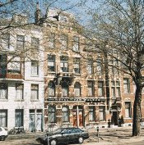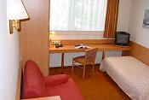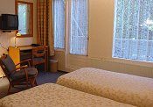
The Hotel is an 100 year old building 1 person room 2 persons room
We agreed with the hotel on a price of € 80.= per night for 1 person rooms and € 100,= per night for 2 persons room, both including breakfast. The is a small lounge which we can use tot have a small morning meeting, if necessary.
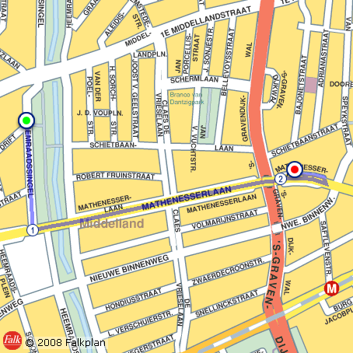
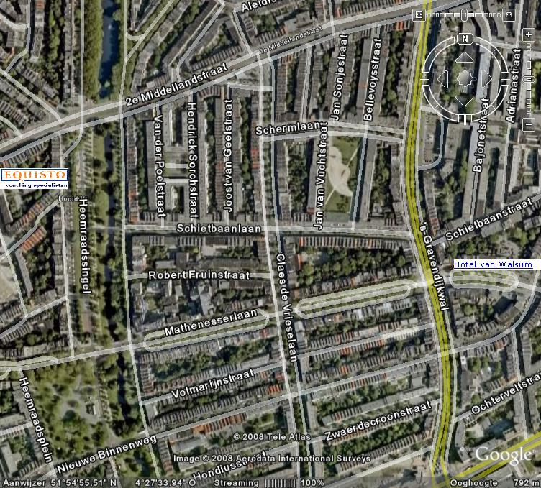

Route from Equisto Office to the Hotel Van Walsum

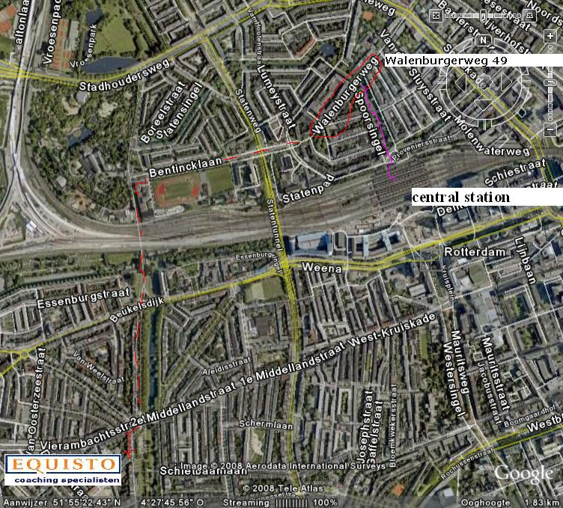

Route from Equisto Office to the Home of your host Hans (red)
at Walenburgerweg 49 and from Central Station to Hans’ Home (purple).

Flight options
Proposal was to fly on Schiphol/Amsterdam. If you consider flying on Bruxelles, here are the train times:
1.
The train from Bruxelles Airport to Rotterdam takes 2 h 15 min. (would be on Saturday 15)
The train from Antwerp to Bruxelles Airport takes 1 h. (would be on Friday 21)
2.
The train from Schiphol (Amsterdam) Airport to Rotterdam takes 51 min. (would be on Saturday 15)
The train from Antwerp to Schiphol (Amsterdam) Airport takes 1 h 50 min. (would be on Friday 21)

